

Exercises Report - Lab 5
LAB 5 -Identifying MITM attacks on GPG keys (Web of Trust)

Course: Cyber Security

Ljubljana, 28/5/2026 Vishnu Viswanath Thattrakkal
Student ID- 35250024

LAB 5 -Identifying MITM attacks on GPG keys (Web of Trust)

INTRODUCTION
The purpose of this lab was to understand the importance of trust in public key cryptography and secure key exchange. The exercise demonstrated how Man-in-the-Middle (MITM) attacks can occur when public keys are not properly verified. It also highlighted the role of fingerprint verification and the Web of Trust in ensuring the authenticity and reliability of public keys
The exercise involves three participants: Alice as the sender, Bob as the recipient, and Mallory as the attacker. All actions are performed on the same device to simulate a real attack environment.
If an attacker manages to inject his public key instead of the real one, he can:
- read all encrypted messages,
- impersonate someone else,
- GPG cannot detect this without trust verification.

Three people participate in the exercise:
- Alice – sender
- Bob – recipient
- Mallory – attacker (MITM)
Everything is done on the same device.

Key Generation
Generated three separate GPG key pairs for the following users:
- Alice (alice@example.com)
- Bob (bob@example.com)
- Mallory (mallory@example.com)
Then verified all keys were created successfully.

- Alice (alice@example.com) (image-1)

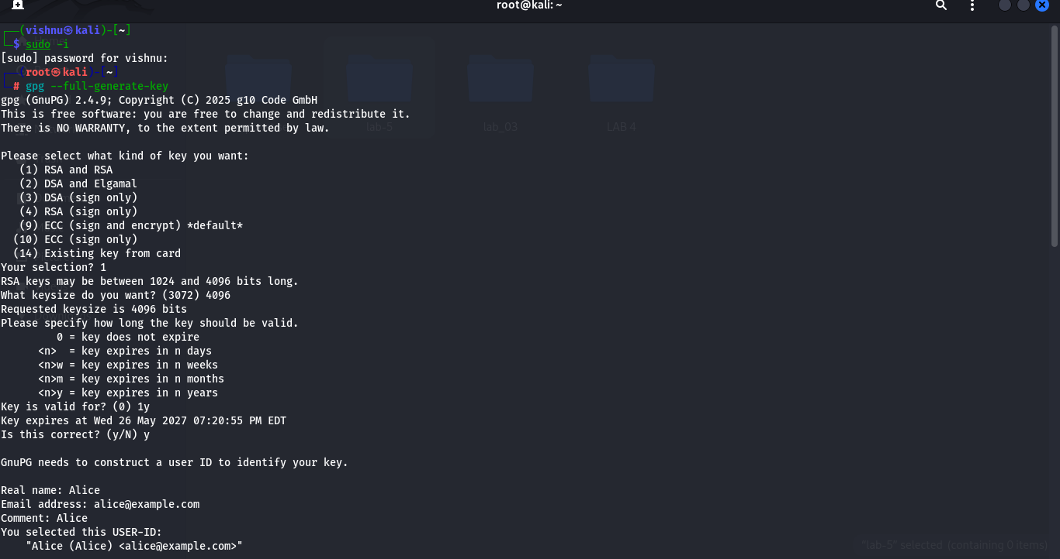
Image -1

- Bob (bob@example.com) Image -2
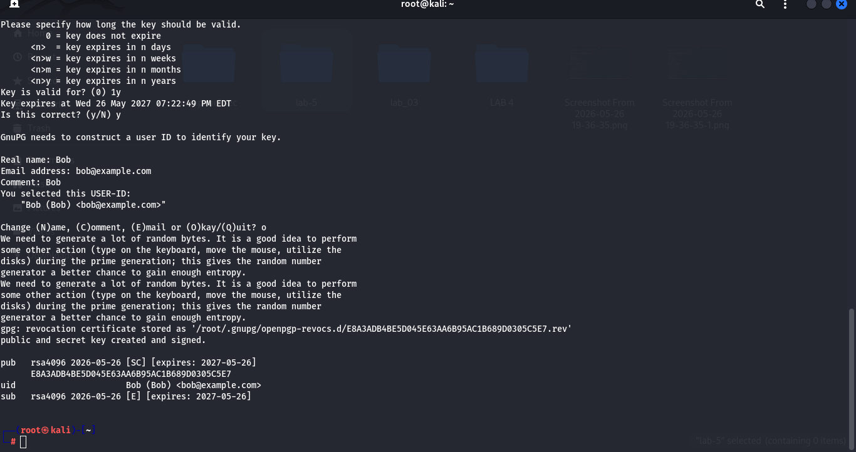
Image -2

- Mallory (mallory@example.com) Image -3

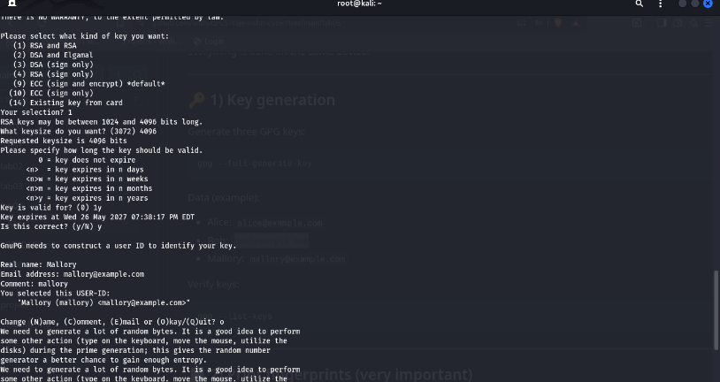
Image -3

Verifying key : gpg --list-keys
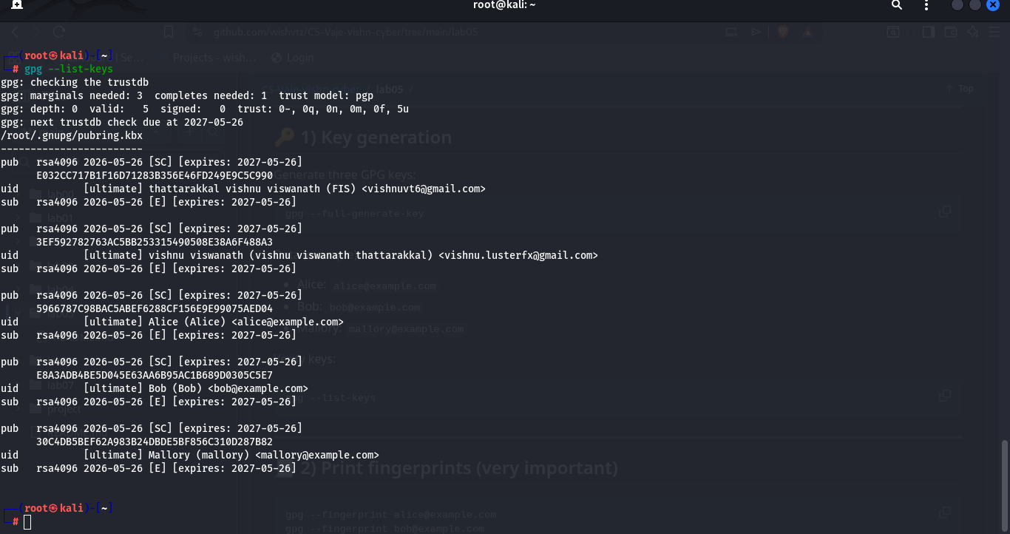
Image -4

Print fingerprints (very important)
Display the unique fingerprint of each GPG key to verify identity and ensure secure key usage.
- gpg --fingerprint alice@example.com
- gpg --fingerprint bob@example.com
- gpg --fingerprint mallory@example.com

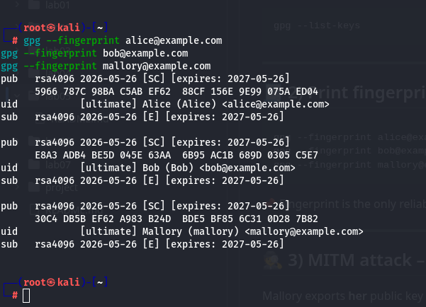

Image -5

MITM attack – key substitution
Demonstrate how a malicious actor (Mallory) can trick a user (Alice) into trusting a fake public key by substituting Bob’s key with her own.
Mallory exports her public key and names it Bob's:
gpg --armor --export mallory@example.com > bob_pubkey.asc
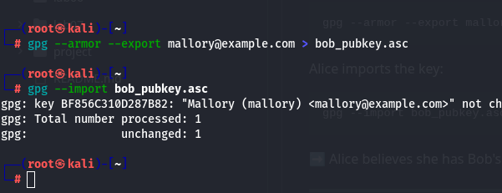
Image -6
Alice imports the key as shown in the image -7
gpg --import bob_pubkey.asc

Alice encrypts the message
Alice attempts to send a confidential message to Bob using GPG encryption. However, due to the earlier key substitution attack, the message is encrypted with Mallory’s public key instead of Bob’s.
- echo "Confidential message for Bob" > secret.txt

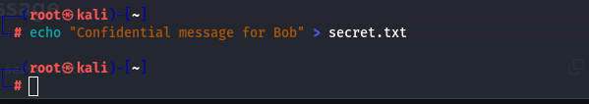
Image -7
- gpg --encrypt --recipient bob@example.com secret.txt
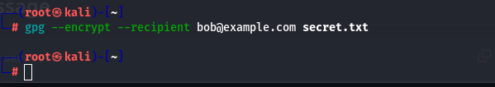
Image-8
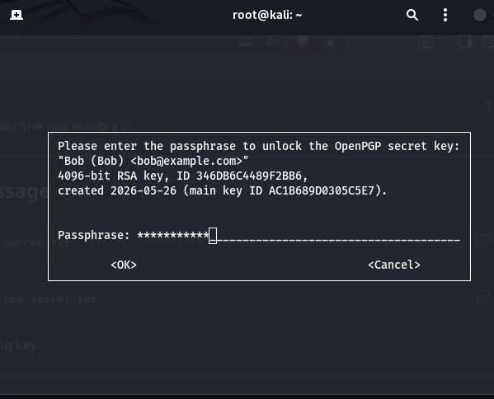
Image -9

Mallory decrypts the message
Mallory demonstrates that the man-in-the-middle key substitution attack is successful by decrypting a message Alice believed was securely sent to Bob.
- gpg --decrypt secret.txt.gpg
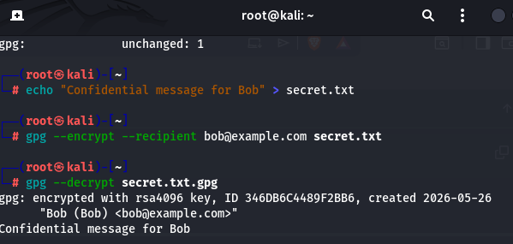

Attack detection – fingerprint verification
Bob sends Alice his correct GPG fingerprint through a trusted channel. When Alice runs `gpg --fingerprint bob@example.com`, the fingerprint does not match, confirming a MITM attack.
- gpg --fingerprint bob@example.com
- 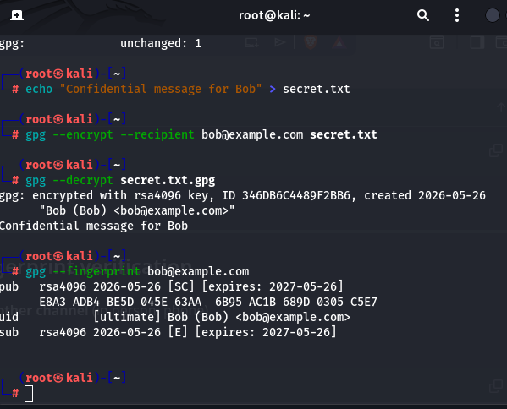
Image -11

Web of Trust – trust setting

Alice sets trust on the verified key: gpg --edit-key bob@example.com
After executing this in the console, I executed as per instruction
- Trust >5>quit
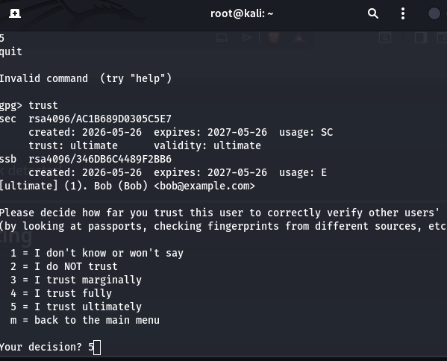
Image -12
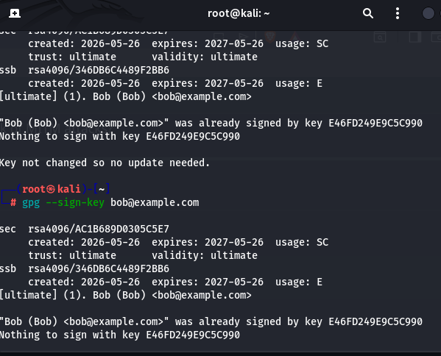
Image -13

Additional challenge
Signing Bob's key with Alice's key: gpg --sign-key bob@example.com
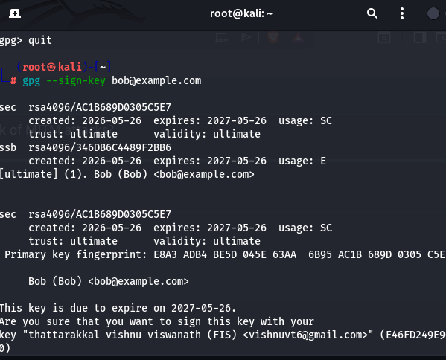
Image -14

Key Differences
- Trust
A level of confidence assigned to a key
Example: Alice sets Bob’s key to “ultimate trust”
- Signed Key
A key that has been verified and digitally signed by another user
Helps others know the key has been authenticated
- Ultimate Trust
Highest level of trust in GPG
Usually assigned to your own key or a fully trusted identity
Used as a starting point for validating others in the Web of Trust

Reflection
1) Why doesn't GPG detect MITM attacks automatically?
GPG cannot detect MITM attacks because it only encrypts using the public key that is already stored locally. If a fake key is imported (like Mallory’s instead of Bob’s), GPG has no way to know it is incorrect without external verification.
2) What is a fingerprint and why is it important?
A fingerprint is a unique identifier of a GPG key. It is important because it is the only reliable way to verify that a public key truly belongs to the correct person and has not been replaced or modified.

3) Why is email not a secure channel for exchanging keys?
Email is not secure because an attacker can intercept or replace keys during transfer. This allows an MITM attack where a fake key can be sent instead of the real one without detection.

4) How does the Web of Trust reduce the risk of MITM attacks?
The Web of Trust reduces risk by allowing users to verify and sign each other’s keys after confirming their identity. Trusted signatures and verified fingerprints help ensure that a key actually belongs to the claimed owner.

